How to Update Your Preferred Name
- Log into your CMA portal and select PeopleSoft- Student Systems
- In your Student Center, navigate to the Personal Information section and select Names
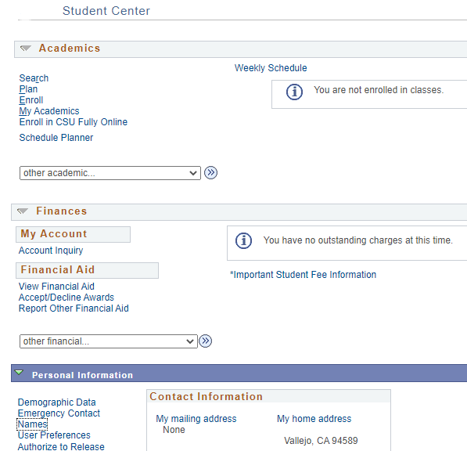

Click on the Add a Name Change button and from the Name Type drop down select preferred name. You can update your first and/or middle name, then click Save. Preferred name changes will appear immediately.
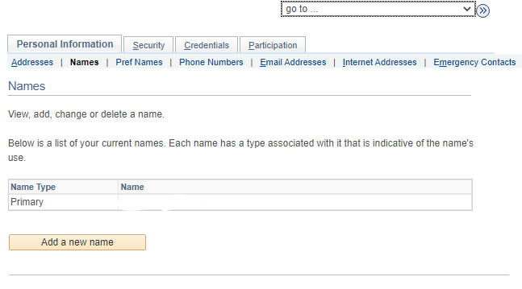

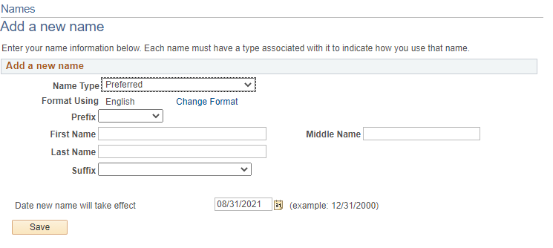

Preferred Name FAQ
- What is a Preferred Name?
A preferred name is a first and/or middle name by which someone wishes to be commonly known if different from their legal first name. Preferred names can be changed in CMA portal PeopleSoft – Student Systems. Unlike preferred name changes, legal name changes must be handled by the Registrar’s Office and requires legal documentation. If your legal name has changed and you would like to update it, please contact the Office of the Registrar.
- Can I set or change my preferred name and pronouns to whatever I want?
You can set a preferred name that you want to be known by in university systems instead of your legal name, where such usage is currently supported. The University reserves the right to remove a preferred name if it is inappropriate or being used for misrepresentation or to evade legal obligations. Will my preferred name be used for everything at the University?
We are using preferred name in as many places as we can. As of right now, your preferred name will appear in the Student Center, the Advisor Center, the Faculty Center include Class and Grade rosters, and Brightspace. Bear in mind that your legal name will continue to be used anywhere a legal name is required, such as official and unofficial transcripts, and any documentation involving financial aid or student accounts. For some of these services, you may need to provide government ID containing your legal name (such as when picking up a check).
- Can I change my email address to match my preferred name?
No. Students are not able to update their email address to their preferred name at this time.
- Can I specify a preferred last name?
No. Last names can be changed only as a result of a legal name change. You must file a Name Change request with the Registrar’s Office or Human Resources to do this.
- Am I required to set a preferred name?
No. Using a preferred name is entirely optional.
- How long will it take for my preferred name to appear and be used by the University?
Once you set your preferred name in PeopleSoft – Student Systems, it will automatically appear and be used in the Student Center, the Advisor Center, the Faculty Center include Class and Grade rosters.
- Do I need to change my password when I set a preferred name?
No. Your password should not be affected by a preferred name change.
- I still have questions. Who can I talk to?
You can contact the Registrar’s Office at registrar@csum.edu

