# *Newsletter from Career Services*

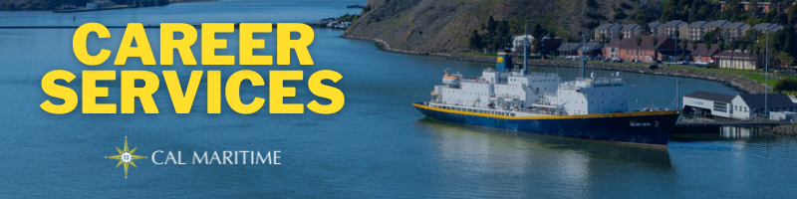

**January 24th, 2022**

## Employer Spotlight – The Dutra Group

The Dutra Group, headquartered in San Rafael, has three operations, dredging, marine construction, and materials, that make up the combine to make up the organization. They provide both maintenance and construction services, while utilizing the San Rafael Rock Quarry for aggregate reserves, which serves as the only waterside distribution center in the SF Bay Area. Check out the intern positions they have posted recently on KCC.

## On the Website

Coming soon, we will be offering a way to request workshops and presentations from Career Services, directly from our webpage. This will be located on our blue navigation bar on the left side of our webpage. Included will be a list of offerings and what to expect with each. Stay on the looking for more information.

Konnecting Keelhaulers is gearing back up and we would like to hear from cadets on alums and employers they would like to hear from. If you have any ideas, whether broad or specific, reach out to [Ryan Rodriguez](http://rrodriguez@csum.edu) to put in a request. As always, we hope to provide a diverse array of experiences for you to learn from.

**Watch all Konnecting Keelhaulers on the** [**CS Page**](https://www.csum.edu/career-center/konnecting-keelhaulers/cadet-interviews.html) **and** [**YouTube**](https://www.youtube.com/playlist?list=PL7mIw9rGiCHSFlfAhHw9O4KqA7x3K5SmV) **and Listen on** [**Spotify**](https://open.spotify.com/show/7A6heWxxAtwGhKEJQRQHkC) **and** [**Anchor**](https://anchor.fm/dashboard)

## Appointments & Walk Ins

Career Services highly encourages you to stop by our offices, located in the Student Services Building, next to the quad. We take both appointments and walk ins, depending on what works with you and our schedule. Appointments in person are encouraged, but we can accommodate appointments via Zoom if that is your style.

[**Schedule an Appointment**](https://www.csum.edu/career-center/schedule-an-appointment.html)

## Advice Section – Application Process

With application season ramping up, Career Services fields many questions from cadets about what to expect in the process. Many center around what to expect and how long does it take for companies and organizations to respond. Compound some of the stress is there is no one answer to be given, much is up to the place you apply to. And you will apply to many.

The simple answer to “what to expect” is a lot of waiting. While you are one person, the places that you apply to are fielding lots of applications, both on one requisition and with multiple requisitions open at a time. Because of this there is lot of sifting through application material that takes much longer than a lone applicant wants. This serves double when you have applied to multiple places. “I just want one of them to respond” is a common exasperation.

Something to remember while waiting, track all your applications. Some use a spreadsheet; others use a Word type document. Whatever your document of choice, make sure to include the title of the position, the company/organization, location of position, date applied, job description (in written form or saved a PDF), the job description link, compensation, if possible, your own notes on the position, and the closing or review date listed. This will help you keep things organized if and when you do get an email or call back.

The closing or review dates are particularly key. This will give you some idea of what timeline to expect. A general rule of thumb is to take the closing date and add two weeks on when to expect outreach from the company. Same with review dates, by having that documented, you can start to gauge when you could potentially hear back. This does not mean an employer will adhere to the two-week timeline, remember, they all have their own processes. By tracking this information, you will have a reference as you get antsy to remind yourself on what to expect. If there is no closing or review date mentioned, pay attention to how long the position you had been posted when you applied. Typically, employers like to have job reqs up for 3-4 weeks to gather a strong candidate pool.

## Career Services Meetings

**Sea Training II Co-Op**

1/25 – 1100 – Rizza Engineering 2/17 – 1100 – Peachman

IBL 2/22 – 1100 – Peachman

GSMA 2/24 – 1100 – Peachman

## Networking Opps

### [**Company Presentations**](https://www.csum.edu/career-center/career-services-events/index.html)

**Chubb Risk Engineering** 2/10 – 1100 – [Zoom](https://csum.zoom.us/j/82876228858)

**Curtin Maritime** 3/2 – 1630 – Location TBA

**Shaver Transportation** 3/2 – 1730 – Location TBA

## NEW ON KCC

**Dutra Group**  
Estimating Intern

Dredging Field Engineer Intern

Marine Construction Field Intern

Equipment Engineer Intern

**Lockheed Martin Corproation**  
Facilities/Plant Engineering Intern

**Calpine Corporation**

Principal Settlements Analyst

Warehouse Technician II

**Flagship Management LLC**  
24 Positions

**Marine Spill Response Corporation**  
Response Supervisor – Concord

Emergency Response Technician (2 locations)

Maintenance Technician

**UCSF Health (thru Able)**  
Stationary Engineer

**JLL**

Plant Building Engineer

**City and County of San Francisco**

TStationary Engineer, Sewage Plant – SFO (7372)

**Promaxo Inc**

Supply Chain/Operations Intern

[**Find more jobs**](https://app.purplebriefcase.com/pb/myJobs/)

[**Find more internships**](https://app.purplebriefcase.com/pb/myJobs/index/interns)

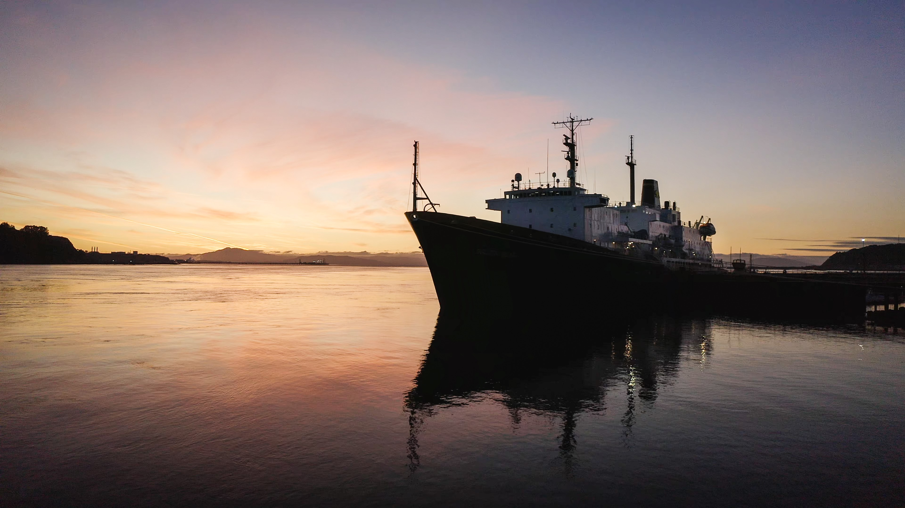

## Make a 1-on-1 with a Career Coordinator

Ryan Rodriguez  
[rrodriguez@csum.edu](mailto:rrodriguez@csum.edu)

Ryan Scheidemantle [rscheidemantle@csum.edu](mailto:rscheidemantle@csum.edu)

Director

Lily Espinoza

[lploski@csum.edu](mailto:lploski@csum.edu)

Admin Assistant

Tess Luna  
[tluna@csum.edu](mailto:tluna@csum.edu)

[**Career Services**](https://www.csum.edu/career-center/schedule-an-appointment.html)  
California State University Maritime Academy