How to clear cache and cookies
For Google Chrome, Edge, Internet Explorer or Mozilla Firefox, you can quickly clear your cache with a keyboard shortcut. While using your browser, press Ctrl+Shift+Delete simultaneously on the keyboard to open the appropriate window. Remember to close the browser and restart it after clearing the cache and cookies.
Screenshots of settings
Google Chrome:  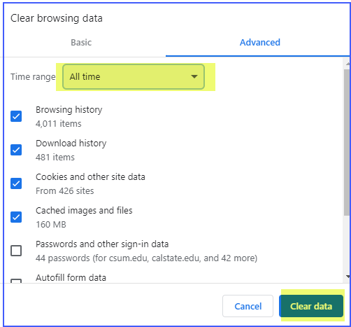 | How to delete history on Google Chrome: Click the Tools menu (i.e., three dotted lines in the upper-right corner).  - Select History.  - Select Clear Browsing Data from the left-hand side. Set the Time Range set to All Time. Check-mark Cookies and other site data and Cached images and files and select Clear Data.  - If you are on a Windows computer, close and reopen Chrome to save your changes. If you are on an Apple computer, go to the Chrome menu on the top menu bar and select Quit for the changes to take effect.
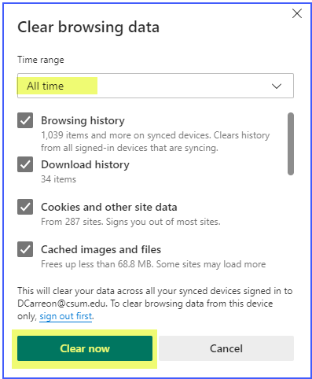  Edge: | How to clear history on Microsoft Edge for Windows 10: Click the Tools menu (three dotted lines in the upper-right corner), and open the Settings menu  - Click Privacy, search, and services on the left-side menu.  - Under the section Clear browsing data, click Choose what to clear.  - Select Cookies and other site data and Cached images and files.  - Click Clear Now.  - Close Microsoft Edge for your changes to take effect.
Explorer: 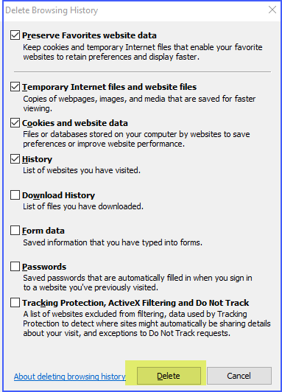 | How to delete on Internet Explorer:  - Click the Tools menu (gear symbol at upper right corner)  - Select the General tab  - Under the section Browsing history click the Delete button.  - check the boxes from the screenshot.  - Click Delete  - Click Apply and then OK  Close Microsoft Edge for your changes to take effect.
Firefox: 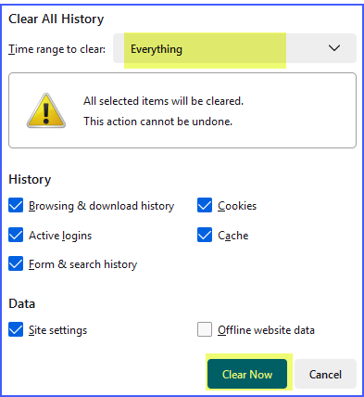 | How to delete history on Firefox:  - Click on the Tools bar  - Click on Settings (On Mac, it is labeled Preferences).  - On the menu to the left, select Privacy & Security.  - Under the Cookies and Site Data option, click the Clear Data button.  - Select only the two options and hit clear now.  If you are on a Windows computer, close and reopen Firefox to save your changes. If you are on an Apple computer, go to the Firefox menu on the top menu bar and select Quit for the changes to take effect.
Mobile Devices
How to clear history on Google Chrome for iOS: Open Google Chrome on your iOS device.  - Click on the menu toolbar in the bottom right corner  - Select Settings.  - Select Privacy.  - Select Cookies, Site Data, and Cached Images and Files. At the top, set the Time Range set to All Time.  - Click Clear Browsing Data at the bottom of the screen.  Confirm by clicking Clear Browsing Data again. | How to delete history on Safari for iOS – how to delete cookies on iPhone:  Go to the Settings app on your device.  - Scroll down to the Safari menu.  - Scroll down and select Clear History and Website Data.  - You will see a pop-up asking if you want to clear the History and Data. Select Clear History and Data.  The button for Clear History and Website Data will turn gray when the cache and cookies have been successfully cleared.

